Create a shell script named analyze.sh that accepts exactly ONE command-line argument.
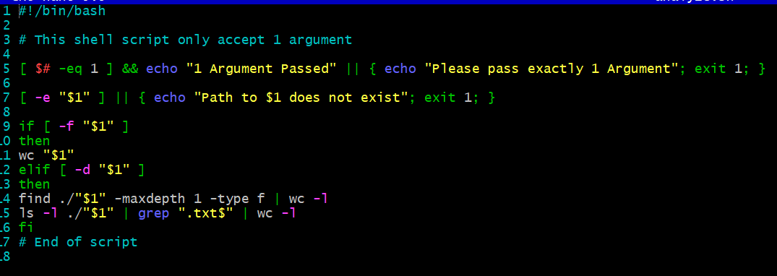
• If the argument is a file: – Display the number of lines, words, and characters in the file.
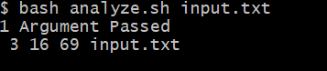
Explanation: My script handles files and print detail using wc command
• If the argument is a directory: – Display the total number of files present. – Display the number of .txt files in the directory.

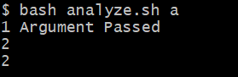
Explanation: if directory is passed, checked with -d option and print all files using find with -maxdept 1 and -type f as parameter, so it does show files only count.
• If the argument count is invalid or the path does not exist: – Display an appropriate error message.
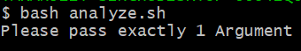
Explanation: Handles errors using if blocks and print error message on the screen and exit the code so it won’t run further.

